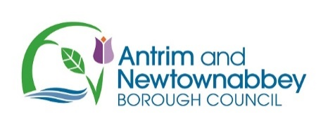

Ballyclare May Fair - Register Your Interest for the Soapbox Derby 2024
Please return your Expression of Interest to Ian Cameron Ian.Cameron@antrimandnewtownabbey.gov.uk.

We will be in touch with further information once the 2024 dates and times have been confirmed.

TEAM NAME ____________________________________________

ALL TEAM MEMBERS DETAILS MUST BE COMPLETED FOR INSURANCE PURPOSES
 | Captain | Team Member | Team Member | Team Member
Name

Address

Phone Number

DOB
Existing Medical Conditions/Injuries
Yes/No. If Yes, please give details

Signature

Please provide additional information about your team or soapbox. This information may be used to introduce you properly to the spectators.

