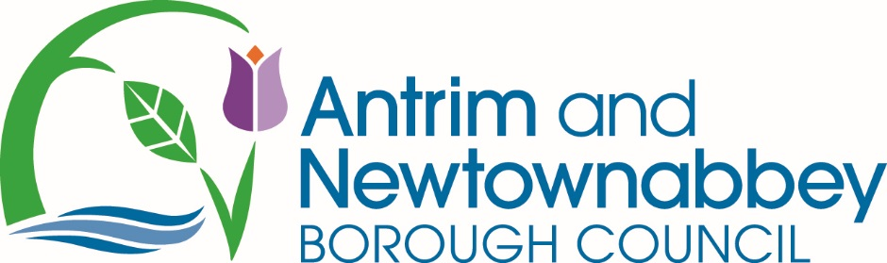

26 January 2022

To: Each Member of the Council

Dear Member

MEETING OF ANTRIM AND NEWTOWNABBEY BOROUGH COUNCIL

A meeting of Antrim and Newtownabbey Borough Council will be held on Monday 31 January 2022 at 6.30 pm.

You are requested to attend.

Yours sincerely
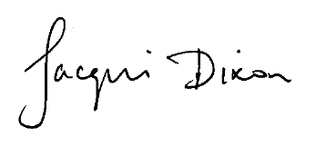

Jacqui Dixon, BSc MBA
Chief Executive, Antrim & Newtownabbey Borough Council

For any queries please contact Member Services:
Tel: 028 9034 0048/028 9448 1301 memberservices@antrimandnewtownabbey.gov.uk

A G E N D A
- Bible Reading and Prayer (In accordance with Standing Orders, Members are not required to attend for this part of the meeting and, following this part of the meeting, Members outside the Chamber will be called to the meeting).
- Apologies

- Declarations of Interest

- To take as read and confirm the minutes of the proceedings of the Council Meeting of Antrim and Newtownabbey Borough Council held on Monday 20 December 2021, a copy of which is enclosed.
- To approve the minutes of the proceedings of the Operations Committee Meeting of Tuesday 4 January 2022, a copy of which is enclosed.

- To approve the minutes of the proceedings of the Policy and Governance Committee Meeting of Wednesday 5 January 2022, a copy of which is enclosed.

- To approve the minutes of the proceedings of the Community Planning Committee Meeting held on Monday 10 January 2022, a copy of which is enclosed.

8(a) To take as read and confirm the Part 1 of the minutes of the proceedings of the Planning Committee Meeting held on Monday 17 January 2022, a copy of which is enclosed.

8(b) To approve Part 2 of the minutes of the proceedings of the Planning Committee Meeting held on Monday 17 January 2022, a copy of which is enclosed.

9 ITEMS FOR DECISION

9.1 Department for Infrastructure Draft Budget 2022-25 Consultation

9.2 Call for Views on New Strategies - Department of Health, Department of Justice and The Executive Office

9.3 SONI Consultation on Draft Transmission Development Plan For Northern Ireland 2021-2030

9.4 Call for Evidence on Northern Ireland District Councils Remote/Hybrid Meetings

9.5 Northern Ireland Water – Presentation Request

9.6 The National Association of Councillors UK

9.7 Review of Council Events 2021-2022

9.8 Tidy Randalstown - Royal Horticultural Society Garden Day 2022

9.9 A6 Randalstown to Toome – Proposed De-Restriction Order

9.10 Belmont Road, Antrim – Proposed Speed Limit Reduction

9.11 New Planning IT System - SLA for Intelligent Client Function

9.12 Disposal of Land Adjacent to Monkstown Boxing Club, Cashel Drive, Newtownabbey

9.13 Consultation by Department for Infrastructure on Planning Application Reference LA03/2020/0881/RM

9.14 Queen’s Platinum Jubilee Working Group

10 ITEMS FOR NOTING

10.1 Northern Ireland Housing Council

10.2 Correspondence from Royal British Legion – Carnmoney/Glengormley Branch

10.3 Motion – Newry, Mourne and Down District Council – Down High School Eco Group

10.4 Changes in Membership of Working Groups by the Alliance Party

10.5 Queen’s New Year’s Honours List

10.6 ESF Match Funding Requests (April 2022 – March 2023)

10.7 Planning Policy Substantial Community Benefit – Loss of Open Space Assessment

11 ITEMS IN COMMITTEE

11.1 Our Prosperity Outcome Delivery Group Minutes

11.2 Strategic Asset Management – Former Landfill Site at Craigmore, Randalstown

11.3 Greenway Project - Hightown/Mallusk to Gideon's Green: Valley Park

11.4 Strategic Asset Management – Land at Steeple Play Park

11.5 Levelling Up Fund Antrim Funding Project - Lease Arrangement

11.6 Garden Show Ireland

11.7 COVID Recovery Small Settlements Regeneration Programme

11.8 Tender for Rathfern Community Centre Extension Works

11.9 Tender Report - Valley Leisure Centre Pitch Drainage

12 NOTICE OF MOTION

Proposed by Councillor Alison Bennington
Seconded by Councillor Jim Montgomery

“This Council resolves to rename the Audit Committee, the Audit and Risk Committee with immediate effect.”

13 NOTICE OF MOTION

Proposed by Alderman Julian McGrath
Seconded by Councillor Neil Kelly

“This Council notes the widespread support across the Borough for the ending of animal cruelty and the improvement of animal welfare; expresses disappointment at the lack of legislative progression on banning the hunting of mammals with dogs in the Northern Ireland Assembly; reaffirms our support for ending this barbaric practice; and agrees to write to DAERA and the Committee for Agriculture, Environment and Rural Affairs to show our support for ending the practice of hunting for mammals with dogs.”

REPORT ON BUSINESS TO BE CONSIDERED
AT THE COUNCIL MEETING ON MONDAY 31 JANUARY 2022

9 ITEMS FOR DECISION

9.1 G/MSMO/008 (Vol 3) DEPARTMENT FOR INFRASTRUCTURE (DfI) DRAFT BUDGET 2022-25 CONSULTATION
Correspondence (enclosed) has been received from the DfI advising of the DfI Draft Budget 2022-25 Consultation.
Full details of the consultation and a link to the survey are available at https://www.infrastructure-ni.gov.uk/consultations/dfi-draft-budget-2022-25equality-impact-assessment-consultation. The survey will be open until Monday 7 March 2022.

Contacts in relation to the consultation are Budget2022-25@infrastructure-ni.gov.uk or by telephone (02890 540472).

Members may wish to respond on a corporate, individual or party political basis.
The Council’s instructions are requested

Prepared and Approved by: Majella McAlister, Deputy Chief Executive of Economic Growth

9.2 G/MSMO/008 (Vol 3) CALLS FOR VIEWS ON NEW STRATEGIES - DEPARTMENT OF HEALTH, DEPARTMENT OF JUSTICE AND THE EXECUTIVE OFFICE

Correspondence (enclosed) has been received from the Department of Health (DoH), Department of Justice (DoJ) and The Executive Office (TEO) advising of the publication of a Call for Views to inform the development of two new strategies relating to;

1. A Domestic and Sexual Abuse Strategy (led by DoJ and DoH)
2. An Equality Safe Strategy: a Strategy to tackle Violence against Women and Girls (led by TEO).
Full details of the consultation, engagement events and link to the survey are available at https://consultations.nidirect.gov.uk/doj/call-for-views-dsa-strategy-vawg-strategy-response/

The survey will be open until Monday 7 March 2022.

Contacts in relation to the consultation are callforviews@justice-ni.gov.uk or by letter to Community Safety Division, Room A4.03, Castle Buildings, Stormont Estate, Belfast, BT4 3SG.

Members may wish to respond on a corporate, individual or party political basis.
The Council’s instructions are requested

Prepared by: Member Services
Approved by: Jacqui Dixon, Chief Executive

9.3 G/MSMO/008 (Vol 3) SONI CONSULTATION ON DRAFT TRANSMISSION DEVELOPMENT PLAN FOR NORTHERN IRELAND 2021-2030
Correspondence (enclosed) has been received from SONI advising of a consultation on the draft Transmission Development Plan for Northern Ireland 2021-2030.
The Transmission Development Plan outlines what projects are needed over the next 10 years in order to support the local economy and decarbonisation, and is updated and proposed for approval annually.
Full details of the consultation and a link to the survey are available at https://consult.soni.ltd.uk/consultation/draft-transmission-development-plan-northern-ireland-2021-%E2%80%93-2030. The survey will be open until 15 March 2022.
Submissions can be made on the consultation portal and by email to info@soni.ltd.uk, and should include “Response to TDPNI Consultation” in the title of any email response.
Responses by post can be made to: TDPNI 2021-2030, SONI Ltd, 12 Manse Road, Belfast, BT6 9RT.
Members may wish to respond on a corporate, individual or party political basis.
The Council’s instructions are requested

Prepared by: Member Services
Approved by: Jacqui Dixon, Chief Executive

9.4 G-LEG-329 CALL FOR EVIDENCE ON NORTHERN IRELAND DISTRICT COUNCILS REMOTE/HYBRID MEETINGS

A call for evidence (enclosed) has been received from the Department for Communities which seeks views on the use of the current arrangements which made provision for district councils in Northern Ireland to hold meetings remotely or in a hybrid format during the coronavirus pandemic.
Full details of the call for evidence and the survey are available at this link. The call for evidence will be open until 5pm on 15 February 2022 and responses should be sent to lgpdconsultations@communities-ni.gov.uk or via post to the address contained within the document.

Members may wish to respond on a corporate, individual or party political basis.
The Council’s instructions are requested

Prepared by: Elaine Keenan, Solicitor
Approved by: Paul Casey, Borough Lawyer & Head of Legal Services

9.5 G/MSMO/017 VOL 3 NORTHERN IRELAND WATER – PRESENTATION REQUEST

Correspondence (enclosed) has been received from Steve Blockwell, Head of Investment Management, Northern Ireland Water, requesting attendance at a future Council Meeting to update Members on what Northern Ireland Water is doing in the Borough, outline the development constraints and what Northern Ireland Water is doing to address these, and share the outcome of the Price Control 21 (2021-2027) Final Determination.

RECOMMENDATION: that the request be accepted and Northern Ireland Water be invited to attend a future Council meeting.

Prepared by: Member Services

Approved by: Jacqui Dixon, Chief Executive

9.6 G/MSMO/21 THE NATIONAL ASSOCIATION OF COUNCILLORS UK

Members are advised that correspondence (enclosed) has been received from the National Association of Councillors UK advising that the NAC UK Conference – Community Empowerment, will take place from Friday 25 to Sunday 27 February 2022 at the Best Western Hotel, Glasgow.

The delegate fee for the Conference is £350 plus VAT and accommodation is available at the conference hotel at £70 plus VAT per night.

Members have not attended any NAC UK events in this or the previous electoral term.

The Council’s instructions are requested.

Prepared by: Member Services
Approved by: Jacqui Dixon, Chief Executive

9.7 ED/ED/080/VOL 4 REVIEW OF COUNCIL EVENTS 2021-2022
Members are reminded that it was agreed at the January 2021 Council meeting to implement a proposed events plan, which would be kept under review with regular updates to be presented to the Council. The plan was developed within the context of COVID restrictions and formed part of the Councils Corporate Recovery Plan.

Within this report Members were reminded that it had been planned to review the Council Events Policy in 2020, however, this had not been possible due to the pandemic and it was agreed that a review of the Council Events Schedule be brought in the future.

Throughout the delivery of events in 2021 Officers have been evaluating all aspects of Council events in order to inform proposals for events in 2022 and create a more efficient approach to the resourcing and delivery of events in the future. The annual events programme consists of a number of event types and delivery models.

The Council events programme is made up of three main types of event:

- Community local events
- Borough Events
- Regional Flagship events which attract visitors from outside the Borough

In addition, there are a range of ways in which events are delivered:

- Council Grant Aid through Community Planning Grant programmes – eg; Antrim Festival Group, VFest, Toome Fair. Officer support provided to these events to assist with various aspects of organisation
- Council Grant Aid through the Tourism Event Sponsorship Fund, e.g.; ISPS Handa, Statsport Supercup NI, May Steam Rally
- Council funding approved by Committee/Council for specific requests, eg; Royal Scottish Pipe Band Association, Antrim Food Festival
- Council events such as the Mayfair, Garden Show Ireland, Town Centre Markets, Enchanted Winter Garden, Summer Sunday Music.

The financial model for events can differ significantly across the categories of event, with many free to participants but others having an admission fee and some a combination of both.

The recovery of events in 2021 has been welcomed by both residents and visitors. Events showcase communities, towns, villages and venues and enhance the Boroughs reputation as a destination to live, work, visit and invest in. Events delivered across the Borough in 2021 supported recovery, contributed to town centre regeneration, gave residents a sense of civic pride and wellbeing and attracted significant numbers of visitors to the Borough.

A key aspect of supporting the retail and hospitality sectors recovery and to support in particular recovery of Town Centres has been the delivery of Town Centre events and animations. This has included Urban Markets over the summer months, live music, Son et Lumiere sound and lighting shows and provision of street theatre. This animation has helped create atmosphere in the Borough towns which has driven footfall and supported recovery. The programme of animation has been supported by marketing campaigns such as #shoplocal and #backinbusiness. It is intended to continue to support town centres recovery and regeneration in 2022 with this type of animation and entertainment in the heart of towns.

Throughout 2021 the Councils NI Centenary Programme has been delivered and has featured civic activity, virtual and online engagement as well as the Giant Weekend of large scale events and a Royal visit to the Borough by HRH The Princess Royal.

A proposed Council events plan for 2022 has been developed with the following aims:

- to continue to support recovery under the themes of People, Place and Prosperity;
- to create a sense of civic pride
- to support the recovery of key sectors such as hospitality, tourism, retail;
- to enhance the reputation of the Borough as an attractive place to live, work, visit and invest in;
- to support delivery of the Council’s tourism offer;
- to maximise the return of the Council’s investment in events through economic benefits;
- to achieve efficient utilisation of resources, improved service delivery and personal and professional development of staff;
- to support community capacity building
- to achieve improved cross-departmental service delivery, internal partnership and external partnership working.

The Council events offer for 2022 includes events which will be staged using all of the delivery mechanisms as follows:

- Community organised events, supported by Community Festival Funding
- Externally organised events, supported by the Tourism Event Sponsorship Fund, many of which are established annual events with a regional audience;
- Externally organised events, which the Council supports in kind or financially through an approval process
- Councils own events organised, managed and funded by the Council

Her Majesty the Queen Platinum Jubilee falls in 2022 and plans are in development to deliver high profile events over the Jubilee Weekend of 2 to 5 June. Council led events will be complemented by a range of community led events, which will be delivered over this weekend with the support of a special Platinum Jubilee Community Events Fund.

The value of the Council’s events programme to all corporate themes has been proven during recovery of events and in this context a proposed events plan by month for 2022 is presented as enclosed. It should be noted that in addition to the events listed there are a range of community events to be delivered with the support of Community Festival Funding with a report being brought to the February Community Planning Committee.

In addition to the events listed, Members are advised that a range of local town centre animations, including music and urban markets are planned for delivery across the Borough from Easter through to the Autumn in a continued effort to support recovery of Borough towns and business, retail and hospitality sectors. This detail is not included given the volume, however Members will be kept updated through DEA engagement meetings and regular updates to the Council. Any further requests for Council support of events either in kind or financial may come in during the year and these will be brought to future meetings as required.

Recommendation: that the proposed Council Events Plan for 2022 be approved with the plan to be kept under review and any updates brought to future meetings as required.

Approved by: Ursula Fay, Director of Community Planning

9.8 PK/GEN/030 TIDY RANDALSTOWN – ROYAL HORTICULTURAL SOCIETY GARDEN DAY 2022

Correspondence has been received from Tidy Randalstown requesting permission to apply for the Royal Horticultural Society (RHS) Garden Day Fund to develop a community garden in the Viaduct area of Randalstown. The map enclosed shows the area in Council ownership. It is not clear at this stage which area would be used if the application for funding is successful, as this will be determined by the garden designer.

To celebrate Garden Day 2022, the RHS is working in partnership with leading garden designers to deliver community gardens worth up to £50,000 as an opportunity to help create an inclusive and welcoming space for everyone in the local community to enjoy. The RHS is prioritising projects that:

- Articulate the wellbeing or environmental benefits a new garden will bring.
- Demonstrate inclusivity by involving a diverse range of groups and individuals.
- Build ongoing connections between the people involved in the project.
- Raise awareness of the importance of plants and gardening for the benefit of all.
- Employ gardening practices that support and benefit the environment.
If successful, the main garden build would take place from March to June 2022. Permission from the owners of the land is required before an application can be submitted.

RECOMMENDATION: that approval is given to Tidy Randalstown, in principle, at this stage, to make an application to the RHS Garden Day 2022 Fund for development of a community garden within the land owned by council at the Viaduct in Randalstown.

Prepared by: Matt McDowell, Deputy Director of Operations (Parks & Leisure)
Approved by: Geraldine Girvan, Deputy Chief Executive of Operations
9.9 G-LEG-LEGAL A6 RANDALSTOWN TO TOOME – PROPOSED DE-RESTRICTION ORDER

Correspondence (enclosed) has been received from the Department for Infrastructure regarding their proposal to de-restrict the A6 dual carriageway on its approach to Drumderg Roundabout at Randalstown West Junction, the B183 Moneynick road on its approach to Drumderg Roundabout and Randalstown West Roundabout, and the A6 Moneynick Road on its approach to the Randalstown West Roundabout.

Members may wish to respond on a corporate, individual or party political basis.
The Council’s instructions are requested

Prepared and approved by: Paul Casey, Borough Lawyer and Head of Legal Services

9.10 G-LEG-LEGAL BELMONT ROAD, ANTRIM – PROPOSED SPEED LIMIT REDUCTION

Correspondence (enclosed) has been received from the Department for Infrastructure advising that they intend to reduce the speed limit on the Belmont Road, between its junction with Belfast Road, Antrim from 50mph to 40mph.
Members may wish to respond on a corporate, individual or party political basis.
The Council’s instructions are requested

Prepared and approved by: Paul Casey, Borough Lawyer and Head of Legal Services

9.11 P/PLAN/010 NEW PLANNING IT SYSTEM – SERVICE LEVEL AGREEMENT FOR INTELLIGENT CLIENT FUNCTION

In June 2020 the contract to deliver a new Planning IT System plus the support and maintenance of the System until June 2030 (and potentially to June 2040) was awarded to Terraquest (TQ). As members will be aware we have been working collaboratively with nine other Councils and the Department for Infrastructure (DfI) and the appointed supplier to deliver the new Planning IT System. This work is currently led by the Regional Planning IT Project Team based in DFI. The System is expected to go live in late summer 2022.

Whilst the system is a managed service it is important that the contract is managed for its duration. It is proposed that when the new Planning IT System goes live to the 11 Planning Authorities (10 Councils and DfI), the responsibility for the day-to-day management of the system will transfer from the Regional project team to Belfast City Council. Belfast City Council will have a dedicated team, referred to as the ICF (Intelligent Client Function) to provide ongoing support, as detailed in the Service Level Agreement (SLA).

The key activities of the ICF will be:
- Central administration of the new Planning IT system
- Manage the contract with TerraQuest, in terms of performance and payments.
- Manage any updates / patches to the system by TQ;
- Manage the process for potential changes and enhancements to the system – proposed by authorities, or by TQ; and
- Act as liaison between Planning Authorities and TerraQuest in the management of any major incidents or outages
- Support the governance arrangements – user groups and service management board.
The ICF will be in place for the duration of the contract for the Planning IT system, until June 2030 (and potentially to June 2040).

The enclosed SLA sets out the roles and responsibilities of the Planning Authorities for the operation and management of the Shared Service including the management of the IT system until the end of the contract with TQ. It also sets out how the costs for the new Planning IT system will be shared between the 11 Planning Authorities.

Annex E outlines the financial costs of the ICF and the breakdown across the 11 Planning Authorities based on the historic levels of planning fees generated by each Authority. The percentage allocation for Antrim and Newtownabbey is 7.69% which over the first five years of the SLA from 2022/23 to 2026/27 is projected to be approximately £20,000 per annum, subject to review after 12 months.

RECOMMENDATION: that the Service Level Agreement for the Intelligent Client Function delivered by Belfast City Council be approved.
Prepared: Kathryn Bradley, Executive Officer, Planning
Approved by: Majella McAlister, Deputy Chief Executive of Economic Growth

9.12 CE/GEN/017 DISPOSAL OF LAND adjACENT TO Monkstown Boxing Club, Cashel Drive, Newtownabbey

Members are advised that a D1 form, a copy of which is enclosed, has been received from Land and Property Services regarding land declared surplus by the Housing Executive adjacent to Monkstown Boxing Club, Cashel Drive, Newtownabbey. Officers have reviewed the information provided and have not identified a need for this asset.

RECOMMENDATION: that the Council does not express an interest in this land.

Prepared and Approved by: Majella McAlister, Deputy Chief Executive of Economic Growth

9.13 P/PLAN/065 CONSULTATION BY DEPARTMENT FOR INFRASTRUCTURE ON PLANNING APPLICATION REFERENCE LA03/2020/0881/RM

The Department for Infrastructure (DFI) has consulted the Council on a Reserved Matters application received for the development of major urban extension in Ballyclare including the northern section of Ballyclare Relief Road.

Application Ref: LA03/2020/0881/RM
Proposal: Reserved matters application for major urban extension to include housing, northern section of Ballyclare Relief Road, public open space and associated development following outline permission granted under U/2009/0405/O
Location: Lands adjacent to the North-West of Ballyclare extending from Rashee Road close to junction with Cogry Road continuing across to the North of Ross Avenue/Clare Heights and North and West of Ballyclare Rugby Club to the North of Doagh Road
Applicant: Ballyclare Developments Ltd

Further Information on this application is available to view at the Planning Portal www.planningni.gov.uk

Officers would advise that the Council is not the decision maker in respect of this application; rather the Council is one of a number of bodies which has been consulted by DFI on the application. Any comments made by the Council will be considered by DFI as part of the processing of the application together with all other consultation replies and other representations received. In addition while the Council has been consulted on the proposed development, there is no obligation on the Council to provide a corporate view.

There are a number of options available to the Council in responding to the consultation by the Department for Infrastructure:

- Provide a corporate view in support of the development.
- Provide a corporate view opposing the development.
- Provide no corporate view on the development. In this case individual Members or parties may express support for or object to the development.

The Council’s Instructions are requested.

Approved by: Majella McAlister, Deputy Chief Executive of Economic Growth

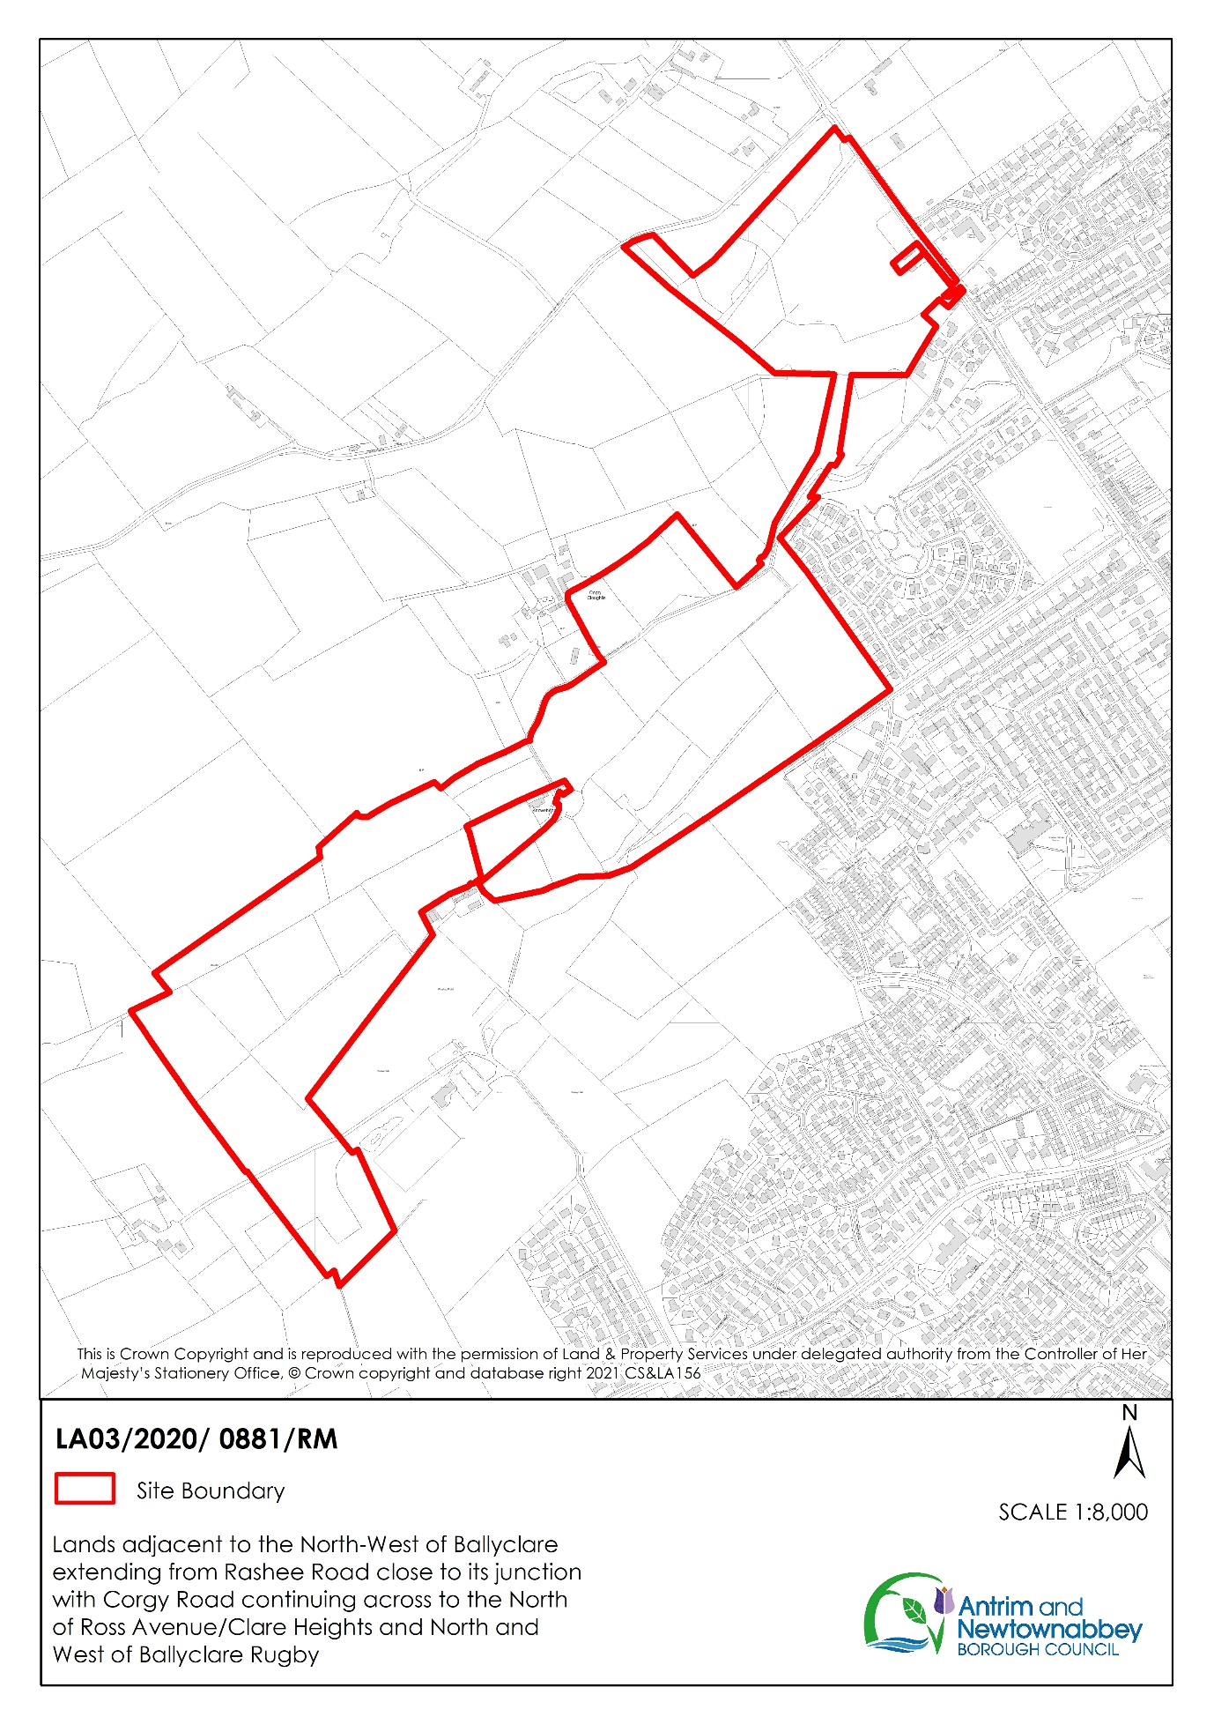

9.14 CP/CP/182 QUEEN’S PLATINUM JUBILEE WORKING GROUP

Members are reminded that Her Majesty the Queen’s Platinum Jubilee Working Group has been meeting monthly since Tuesday 21 September 2021, with the minutes of the meeting of 14 December 2021 approved at the January 2022 Community Planning Committee. A further meeting of the Working Group was held on Wednesday 19 January 2022 and the minutes are enclosed for Members’ information.

At this meeting it was agreed that the civic buildings be lit purple on 6 February 2022 to mark the date of the accession of Her Majesty the Queen to the throne. This request has been considered under the current Council Light Up Civic Buildings Policy and referred to the Light Up Working Group. Approval of this request required all 5 Members to agree, whilst four members approved the request Sinn Fein abstained, so approval for this light up is required by the Council.

RECOMMENDATION: that

- the minutes of Her Majesty the Queen’s Platinum Jubilee Working Group meeting of 19 January 2022 be approved;
- the request to light civic buildings purple on 6 February 2022 to mark Her Majesty the Queen’s accession to the throne be approved

Prepared and Approved by: Ursula Fay, Director of Community Planning

10 ITEMS FOR NOTING

10.1 CE/OA/013 NORTHERN IRELAND HOUSING COUNCIL
As agreed at the August 2019 meeting of the Council, the Northern Ireland Housing Council’s January 2022 monthly bulletin is enclosed for Members’ information. A copy of the minutes of the Housing Council meeting in December is also enclosed.
RECOMMENDATION: that the report be noted.

Prepared by: Member Services
Approved by: Jacqui Dixon, Chief Executive

10.2 G/MSMO/107 CORRESPONDENCE FROM ROYAL BRITISH LEGION – CARNMONEY/GLENGORMLEY BRANCH

Correspondence has been received from the Royal British Legion – Carnmoney/Glengormley Branch in relation to the 2021 Remembrance Service and advising on the Poppy Appeal total to date.

A copy of the correspondence is enclosed for Members’ information.

RECOMMENDATION: that the report be noted.

Prepared by: Member Services
Approved by: Jacqui Dixon, Chief Executive

10.3 G/MSMO/14 MOTION – NEWRY, MOURNE AND DOWN DISTRICT COUNCIL – DOWN HIGH SCHOOL ECO GROUP

Members are advised that correspondence has been received from Newry, Mourne and Down District Council regarding a Motion adopted by that Council and requesting support.

A copy of the letter is enclosed for Members’ information.

RECOMMENDATION: that the correspondence from Newry, Mourne and Down District Council be noted.

Prepared by: Member Services

Approved by: Jacqui Dixon, Chief Executive

10.4 G/MSMO/002 CHANGES IN MEMBERSHIP OF WORKING GROUPS BY THE ALLIANCE PARTY

Following the redesignation of Councillor Finlay as an Independent Member, the Alliance Party Nominating Officer has advised of further changes in Memberships to Working Groups with immediate effect as follows:

Community Planning Partnership | Councillor Julie Gilmour
Our Place ODG (Chair) | Councillor Neil Kelly

RECOMMENDATION: that the report be noted.

Prepared by: Liz Johnston, Head of Governance

Agreed and Approved by: Sandra Cole, Deputy Chief Executive of Finance and Governance

10.5 G/MSMO/123 QUEEN’S NEW YEARS HONOURS LIST
In Her Majesty the Queen’s New Year’s Honours list for 2022, a number of people living and working in the Borough were recognised. The Mayor has written to those honoured and congratulated them on behalf of the Council in recognition of this wonderful achievement.
RECOMMENDATION: that the report be noted.
Prepared by: Mayor’s Office

Approved by: Jacqui Dixon, Chief Executive

10.6 ED/ED/102 ESF MATCH FUNDING REQUESTS (APRIL 2022 – MARCH 2023)

Members may be aware that the Department for the Economy has invited applications for funding from the European Social Fund (ESF) for programmes to be delivered between April 2022–March 2023 as the current programmes of support (2018–2022) will cease on 31 March 2022. The funding structure is 65% funding through the Department and ESF fund (50% ESF and 15% DFE), with 35% to be provided by the applicant through other public or private match funding.
The programmes will fund activity to enhance and extend employment opportunities, in particular for those groups at a disadvantage in the labour market who are unemployed, including long term unemployed, or economically inactive. There will also be a focus on supporting young people aged 16-24 who are not in employment, education or training and on people with a disability. Typically, programmes will include one-to-one mentoring support for participants and include training and work placements to help move them into employment. The programme in 2022-23 will run alongside other employability initiatives which will be delivered through the Labour Market Partnership, and cannot be funded through this Action Plan budget.
In the current financial year, the Council awarded match-funding support to seven projects delivering support under the ESF 2018 – 2022 programme, worth a total Council investment of £96,000.
The Council has been approached by eleven projects for match-funding in 2022-23, following a successful outcome in relation to their ESF bid. As shown in the table below, the total project cost is £8,330,473 with 65% to be provided by ESF and DFE totalling £5,414,807.
The remainder of £2,915,666 is to be secured from other sources including other Central Government Departments and Councils. No decisions have yet been made by the relevant Central Government Departments of whom the greatest percentage of this match funding has been requested.
The requested match funding from the Council is £343,634. Officers have reviewed the number of participants benefitting from each programme and the projects jobs created which is also included in the table below. A summary of each project is detailed on the enclosure.

Project Promoter | Total Project Cost | (European Social Fund (ESF) and Central Govt (CG) Funds) |  | Match Funding Requested from ANBC | Number of Participants within ANBC Area | Number of Jobs created in ANBC Area
 |  | ESF 50% (Confirmed) | CG 15% (DFE Confirmed)
Ulster Supported Employment Limited (USEL) | 1,002,440 | 501,220 | 150,366 | 12,500 | 20 | 8
The Bytes Project | 356,149 | 178,075 | 53,422 | 10,595 | 28 | 4
The Prince’s Trust: Project 1 | 1,988,272 | 994,136 | 298,241 | 35,497 | 43 | 6
The Prince’s Trust: Project 2 | 789,907 | 394,954 | 118,486 | 13,910 | 32 | 6
Network Personnel Ltd | 813,785 | 406,893 | 122,068 | 162,757 | 84 | 16
Enterprise Northern Ireland | 459,892 | 229,946 | 68,984 | 22,741 | 55 | 20
GEMS Northern Ireland Ltd. | 466,398 | 233,199 | 69,960 | 10,667 | 20 | 5
Workforce Training Services | 261,720 | 130,860 | 39,258 | 6,726 | 20 | 6
NOW Group | 1,301,526 | 650,763 | 195,229 | 25,000 | 40 | 10
Ashton Community Trust | 744,647 | 372,324 | 111,697 | 28,667 | 103 | 17
Access Centre NI | 145,737 | 72,869 | 21,861 | 14,574 | 10 | 2
TOTAL | 8,330,473 | 4,165,236 | 1,249,571 | 343,634 | 455 | 100

RECOMMENDATION: that the report be noted.

Prepared by: Emma Stubbs, Business Development Manager

Agreed by: Colin McCabrey, Head of Economic Development

Approved by: Majella McAlister, Deputy Chief Executive of Economic Growth

10.7 P/FP/LDP/01 PLANNING POLICY SUBSTANTIAL COMMUNITY BENEFIT – LOSS OF OPEN SPACE ASSESSMENT

Members are reminded that, until such times as the Council agrees a policy, the following process was agreed in December 2021 in relation to a proposal from a developer regarding community benefit involving a planning application where there is a loss of open space: Elected Members from the relevant DEA(s) are consulted on the developer’s proposals regarding community benefit. The outcome of this consultation will be brought to the Council for information and following this, Planning Officers will progress the application under the normal development management process.

Since then Officers have progressed this process in relation to two planning applications and it has become apparent that the process may create a perceived conflict of interest for Councillors who are Members of the Planning Committee. Therefore, the Borough lawyer has recommended that planning applications of this nature should be considered by the Planning Committee only and that if those Councillors who are not Members of the Planning Committee wish to express a view on the proposal they should do so by exercising their speaking rights at Planning Committee.

RECOMMENDATION: that the report be noted.

Prepared by: Paul Casey, Borough Lawyer and Head of Legal Services
Approved by: Jacqui Dixon, Chief Executive

