Food Hygiene Rating Scheme: Request for a re-rating inspection | 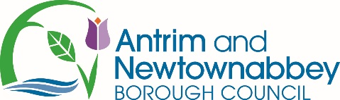 | 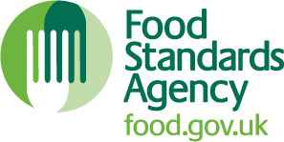

Notes for businesses:
Please read the privacy notice located at the back of the form

Notes for businesses:
- As the food business operator of the establishment you have a right to request a re-visit for the purposes of re-rating under section 4 of the Food Hygiene Rating Act (Northern Ireland) 2016 as amended at any time, provided that you have paid the cost of the re-rating inspection of £150.00 in accordance with section 4(7) of The Food Hygiene Rating Act (Northern Ireland) 2016 and the following conditions are met:-
- Any appeal against the current food hygiene rating has been determined or abandoned:
- You must provide details of the improvements made to hygiene standards with your request, including supporting evidence where appropriate.

If the district council considers that you have provided sufficient evidence that the required improvements have been made.
- The district council officer will give you a ‘new’ food hygiene rating based on the level of compliance that is found at the time of the re-visit - you should be aware that your rating could go up, down or remain the same.
- To make a request for a re-visit, please use the form below and return it to the food safety officer from your district council – contact details are provided with the written notification of your food hygiene rating.
- The re-rating visit will take place within 3 months of the request being made and will usually be made without prior notification.

Business details
Food business operator/proprietor

Business name

Business addresses

Business tel. number |  | Business email

Inspection details
Date of inspection |  |  | Food hygiene rating given
Action taken
Please describe the remedial action you have taken with reference to the issues identified in the inspection letter/report provided to you by your district council with your score:
Compliance with food hygiene and safety procedures

Compliance with structural requirements

Confidence in management/control procedures

Please provide any other supplementary evidence (e.g. photographs, invoices, copies of relevant HACCP documentation etc.).

Signature
Name in capitals

Position |  | Date
Please return this form to: Environmental Health Department, Antrim and Newtownabbey Borough Council, Mossley Mill, Newtownabbey, BT36 5QA

Privacy Notice

We are collecting information from you for the purposes of fulfilling the Council’s statutory obligations. This is in accordance with the relevant legislation, which can be viewed at http://www.antrimandnewtownabbey.gov.uk Information collected may be shared with other statutory agencies/government bodies to fulfil the Council’s statutory functions. Information will not be transferred to countries outside the EEA. All information collected and processed may be subject to audit. The Council may also process the information for research purposes carried out in the public interest. All information will be held in accordance with the Council’s retention and disposal schedule (http://www.antrimandnewtownabbey.gov.uk/Council) and will be disposed of securely when no longer required. You have a number of rights with regard to data we hold on you – for further information see the Information Commissioner’s website https://ico.org.uk/for-organisations/guide-to-the-general-data-protection-regulation-gdpr/individual-rights/
If at any point you believe the information we process on you is incorrect you can request to see this information and even have it corrected or deleted. If you wish to raise a complaint on how we have handled your personal data, you can contact our Data Protection Officer who will investigate the matter:
Data Protection Officer
Antrim Civic Centre, 50 Stiles Way, Antrim, BT41 2UB
T: 028 94 463113
E: DPO@antrimandnewtownabbey.gov.uk

If you are not satisfied with our response, or believe we are not processing your personal data in accordance with the law, you can complain to the Information Commissioner’s Office (ICO).

