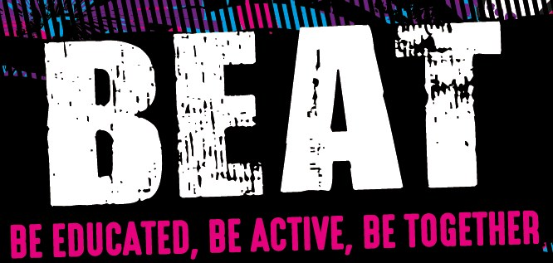

Child’s Full Name: ____________________________________________________________
Date of Birth: ____________________________________ Age: ______________
Address: ____________________________________________________________ _______________________________ Postcode:__________________
Persons to contact in an emergency:
Contact 1  Name: ______________________________  Address:_____________________________  ____________________________________  Postcode:____________________________  Tel (Home): __________________________  Tel (Mobile): _________________________  Relationship to child:__________________ | Contact 2  Name: ________________________________  Address:_______________________________  ______________________________________  Postcode:______________________________  Tel (Home): ____________________________  Tel (Mobile): ___________________________  Relationship to child:____________________

Medical Statement

Does your child have any of the following conditions? (If yes, please tick the relevant boxes)

Any major illness Epilepsy

Blackouts/Headaches/Migraine/Dizziness Diabetes

Allergies to bites/Food/Medicine Heart Complaints

Asthma/Bronchial Illness Back/Neck Complaints

Recent injuries/operation Behaviour Conditions (e.g. ADHD)

Details of the above or any other condition: __________________________________________
_____________________________________________________________________________________

Details of any medication or dietary needs:_________________________________________

(Please bring any medication/inhalers with you on the day)

Terms & Conditions:
1.Event organisers reserve the right to cancel at short notice. 2. Event organisers reserve the right to request participants to leave the event if their behaviour is likely to endanger the safety of others or themselves. 3. Entry fees are non-refundable. 4. Due to the nature of some activities, event organisers reserve the right to change activities at short notice. 5. All participants take part at their own risk and no liability whatsoever shall be attached to Antrim and Newtownabbey Borough Council, its servants, agents or employees in respect of personal loss or damage, however caused, as a result of negligence of the participants or agents.

- My child can have photographs taken and be involved in video footage of the event for promotional purposes by Antrim and Newtownabbey Policing and Community Safety Partnership (PCSP) and its partners.

Yes No

- I consent to emergency medical treatment to be provided to my child if deemed necessary during the course of the Programme.

Yes No

- My child can participate in all activities as part of the programme, which includes a range of physical/sporting activities, awareness and education on issues such as drugs & alcohol, mental health, sexual health, good relations issues and engagement with a range of statutory organisations. This list is not exclusive and if you have any concerns or for more information you should contact the event organisers.

Yes No

- My child can participate in field trips on foot (not leaving the local area) as part of their participation in the programme.

Yes No

- My child can participate in an evaluation survey. All information will be held confidentially, it will not be possible to identify individuals from the surveys and results which will only be shared with organisations who are involved with the programme.

Yes No

I have read and agree to the terms and conditions of entry:

Print Name: ________________________________________________________________________

Signature: ___________________________________________ Date: ___________________

